**KGS-B10-12V** **Remote****Switch**

**Wireless remote control switch is a wireless control device widely used, using microprocessor intelligent control, it can be used in submersible pump control, light control, remote curtain and other fields, with the advantages of easy installation, simple use, safety and reliability.**

Note: The product has been matched before shipment. Please do not press the learning button. It can be used directly after it is powered.

I. **Applications:**

Garage doors, home appliance switches, wireless controls, and other wireless controls.

II. **Technical specifications:**

1. Rated voltage: 12VDC.

2. Static current: ≤ 8mA

3. Control voltage and current 10A 30VDC,10A 125VDC

4. Operating frequency: 315MHz, 433.92MHz,special frequency can be customized.

5. Control mode: Interlock type (L), inching type (M), self-locking type (T)

When welding T, it is self-locking; when short connecting M, it is inching; when neither M nor T is short connecting, it is interlocking

6. Control routes: 1 routes

7. Learning code method: After the power is turned on, the signal led on. Press the learning button once and the signal led flashes. At this time, press the remote control button and the signal led goes out, learning code successful.

8. Clearing code method: After power is turned on, the signal led on. Press the learning button for 8 seconds and the signal led goes out. clearing code successful.

**III.Connection Method:**

DC12V input

Positive +

Negative -

NO is the normal open

NC is normal close

COM is the common port

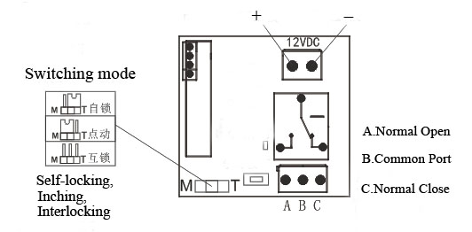

**IV. Matters Needing Attention:**

Warning: This product is a strong electric product, non-professionals do not operate.

1. Please read the instructions carefully before installation and make the wiring in strict accordance with the wiring diagram. Please do not operate with live wiring, otherwise the consequences shall be borne by yourself.

2. Do not operate the keys of the remote control quickly and frequently, because the wireless receiving controller is controlled by the microprocessor, and each operation state has 1 second time response.

3. If the signal led on the remote control becomes dark or the remote control distance becomes short, please replace the battery in time (Warm tip: For the sake of our living and storage environment, please pay attention to the recycling of used batteries and do not discard them at will).The remote control is for precision electronic manufacturing. Please do not fall heavily or get water, otherwise it will damage the product and affect the use.

4. Before installation, please straighten all the spiral antennas of the receiver to the outside of the housing and place them vertically with better sensitivity.

**Manufacturer**: Shenzhen Kaige Electronics Co., Ltd.

**Address:** 1303, Block C, Building 3, Yunzhi Science Park, Guangming Dist, Shenzhen. China

**Telephone:** (+86) 755-2956 4861

**Website :** [https://szkaige. com](https://szkaige.en.alibaba.com)

**Email:** jack@szkaige.com